Sample Format of a Tribal Environmental Plan

The following outline includes different components a Tribe may consider including in their environmental plan. There is no requirement that this particular format be used.

I. Introduction
A. Geography, History and Current community information - Briefly describe location of the community, access to the community, history of the community, current number of residents, current number of homes, major industries, etc.
B. Purpose, Goals and Vision Statement - Describe the purpose of the Environmental Plan and identify the goals of the environmental program.
C. Environmental Program Description - Briefly describe the environmental program.
Include its available resources (number of staff, current grants, technical expertise, and roles and responsibilities within the Tribe.)

II. Prioritized Environmental Issues and Solutions
1. Urgent Environmental Issues #1
A. Briefly describe a high priority environmental issue.
B. Describe if any action was taken and the results if there has been work done.
C. Feasible Solutions - Describe the strategy the Tribe will take to remedy this
Problem. Also describe what you have and what you need for each solution.
(1) Solution #1
(2) Solution #2
(3) Solution #3 program)
D. Resource Needs and Potential Resources - Describe the technical and financial resources needed to implement the identified solutions and how these needs will be met. Identify the actual and potential funding sources (EPA, IHS, USDA, Tribe, loans, private foundations, etc.) and technical assistance (RCAC circuit riders, training courses, consultants, etc.) available to accomplish the identified solutions.
E. Create a timeline for each solution. List out who will be responsible to check on each action taken.
2. Urgent Environmental Issues #1
A. Briefly describe a high priority environmental issue.
B. Describe if any action was taken and the results if there has been work done.
C. Feasible Solutions - Describe the strategy the Tribe will take to remedy this
Problem. Also describe what you have and what you need for each solution.
(1) Solution #1
(2) Solution #2
(3) Solution #3 program)
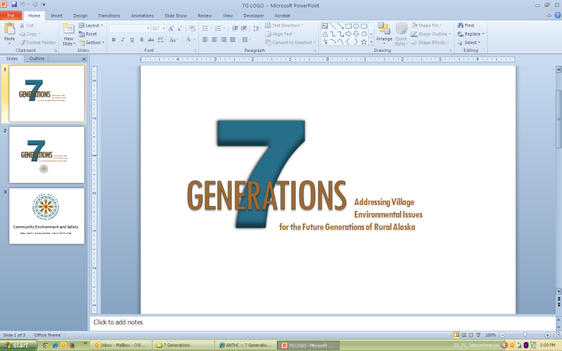
D. Resource Needs and Potential Resources - Describe the technical and financial resources needed to implement the identified solutions and how these needs will be met. Identify the actual and potential funding sources (EPA, IHS, USDA, Tribe, loans, private foundations, etc.) and technical assistance (RCAC circuit riders, training courses, consultants, etc.) available to accomplish the identified solutions.
E. Create a timeline for each solution. List out who will be responsible to check on each action taken.
III. Appendices
May include Surveys and results, meeting notes, project photos, educational material, and any other Plans (Recycling Plan, Solid Waste Management Plan.)

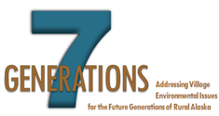
ANTHC Updates 09/2014
ANTHC – Updated 09/2014
ANTHC – Updated 09/2014

