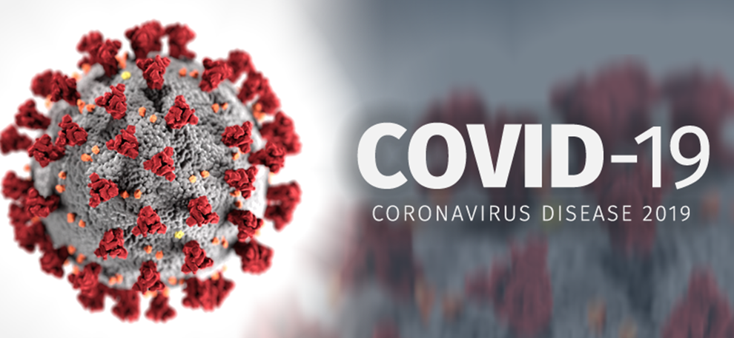

Rural/Frontier Community Response
Tabletop Exercise

Facilitator Guide

April 1, 2020

Table of Contents
I. Overview 3
II. Exercise Purpose 3
III. Exercise Objectives 3
IV. Exercise Outcomes 3
V. Tabletop Structure 4
VI. Tabletop Timeframe 4
VII. Target Audience 4
VIII. Exercise Logistics 5

Overview

The COVID-19 Tabletop Exercise (TTX) is designed for Alaska’s Rural and Frontier Communities to enhance preparedness for and response to the COVID-19 Pandemic. The TTX uses a progressive scenario with specific points of discussion to consider the impact of the pandemic and assess existing plans, procedures and capabilities. The aim of the TTX is to strengthen the readiness against the virus through a series of facilitated group discussions.

Exercise Purpose

- To provide an opportunity for the rural/frontier community leaders and responders to evaluate current response concepts, plans and capabilities in response to COVID-19.
- To enhance your “real world” communications, planning, and response to COVID-19 as it comes to your community.

Exercise Objectives

- Improve preparedness to respond to COVID-19 in rural/frontier communities.
- Evaluate the community’s capability and capacity to safely identify, isolate, and care for a person positive for COVID-19, symptomatic or asymptomatic.
- Assess the notification and communication processes, internally and externally.
- Identify strengths, gaps, and resource needs.
- Enhance collaboration among leaders and responders in the community.
- Confirm your organization's roles/responsibilities and identify how you fit in with your emergency response partners.

Exercise Outcomes

- Identify the main risks an outbreak will pose/is posing in terms of current response procedures and capacities.
- Identify and agree on next steps and timeframes to strengthen preparedness and response to COVID-19.
- Better understand the roles/responsibilities and methodologies to work with counterparts and other external partners.
- Be familiar with guidelines, documentation, and tools available to assist in planning and responding to the pandemic.
- Team building, in support of managing a response to COVID-19

Tabletop Structure

The Tabletop consists of six modules. Each module represents the identification and level of the COVID-19 virus in the rural/frontier community. The modules include:

- Module 1: Prevention/Mitigation - No Known COVID-19 In the Community
- Module 2: Testing - Suspect Case for Testing
- Module 3: Response - Confirmed Positive COVID-19 Case(s)
- Module 4: Surge - Increased Number of Cases
- Module 5: Fatality Management
- Module 6: After Action Discussion and Next Steps

Each community can determine what modules to use, depending on the actual timeframe and evolution of COVID-19 in the community.

The TTX slides can be changed and customized to the situation and needs of the community. Adapting the slides to meet the specific and unique needs of the community is essential for the success of the exercise; this is what makes the simulation/scenario “real” to participants and makes the TTX effort worthwhile.

Tabletop Timeframe

Each module is expected to last approximately two hours, depending on the level of discussion and participation. Again, the facilitator and participants may determine which modules to conduct, according to the evolution of COVID-19 in the community.

Target Audience

The target audience for the TTX include community leaders and influencers, and those who manage critical infrastructure and services. Whole community participation and collaboration will be important.

At a minimum, participation should include the following:

- City / Tribal Administrator
- Clinic / Hospital
- VPSO / Fire / EMS / VPO / TPO / Search & Rescue
- Community Emergency Manager / LEPC Members
- School Administrators
- Food and Housing Service Providers
- Public Works / Utilities / Transportation
- Elders
- Critical Industry
- Airline Agent
- Faith-based Representative
- Translators

Exercise Logistics

Location

- Avoid gathering in one location to conduct the TTX to promote physical distancing.
- What are the customary methods of communication in the community, including remote locations/participation in the exercise? Consider conducting the exercise via Webinar or Skype (preferred) or teleconference.

Exercise Roles

- Facilitator. The role of the facilitator is to lead the preparation for and conduct of the TTX. The facilitator should be someone familiar with the community who will be able to facilitate inclusive, collaborative, and supportive communication.

Facilitator tasks include:
- Distributing the pre-exercise preparation materials at least 2 days (if possible) prior to the exercise, including 1) the Gap Assessment and 2) the Small Community Emergency Response Plan (SCERP) information found at https://ready.alaska.gov/Plans/SCERP.
- Adapting the materials to the community specific context.
- Completing the practical arrangements (e.g., invite participants, space, technology IT set up).
- Conducting the exercise including the presentation of all information in the modules.
- Facilitating the discussion process by asking specific leading questions.
- Observing the group dynamics and assess how the group is achieving the objectives of the exercise.
- Preparing for the debriefing/after action by assessing the substance of the work undertaken during the simulation.
- Drafting the exercise report together with recommendations and follow up actions to be undertaken, with a timeline for completion, and directly linked to the WHO Operational Readiness Benchmarks for COVID-19.
- Adapting the TTX materials to the rural/frontier community specific context.
- Determining the timeframe for the module(s), including breaks.
- Completing the practical arrangements (e.g., invite participants, space, technology/IT set up).
- Conducting the exercise, including the presentation of all materials, scenario, and discussion questions.
- Observing the group dynamics and assessing how the group is achieving the objectives of the exercise.
- Prepare for the debriefing/after action discussion by assessing the substance of the work undertaken during the simulation.
- Print/distribute the exercise materials to participants.
- Draft the exercise report with the Documenter with recommendations and follow up actions to be undertaken, with a timeline for completion.

- Scribe/Documenter. The role of the scribe/documenter is to take notes during the exercise, capturing key lessons and recommendations. Will work with the Facilitator to complete a report of the exercise. If there are issues or questions that arise during the exercise that are not specific to the exercise topic(s), the Documenter will capture those items for later discussion/action.

- Timekeeper. The timekeeper will monitor the time and assist in keeping the exercise on track.

Pre-Exercise Materials

Materials will need to be distributed to participants prior to the exercise at least two (2) days in advance if possible.
- Gap Assessment: This should be completed by the appropriate discipline/participant prior to the exercise. This will serve as a reference and readiness tool and prepare the participant to discuss issues.
- The Alaska Small Community Emergency Response Plan found at https://ready.alaska.gov/Plans/SCERP.

Contacts

For TTX help or questions, please contact:

Name of Person
Title
Alaska Department of Public Health, Section of Public Health Nursing
Email
Phone

