ATV Safety
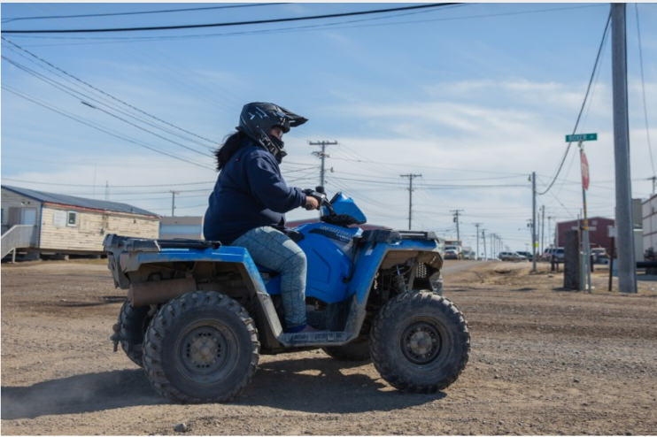
All-terrain vehicles are popular in Alaska for good reason. Especially in rural communities, ATVs are often the best tool for the job. However, the more we use ATVs, the more we need to remind ourselves about ATV safety. Over a 2-year period, at least 20 deaths and 583 injuries from ATV accidents happened in Alaska alone. Many accidents happen when children drive ATVs, but injuries also happen when the driver practices unsafe behaviors like not wearing protective equipment, driving drunk, or speeding.
Safe riding tips:
- Be aware of hazards like objects hidden under snow or wire fences.
- Double check ice conditions before traveling on frozen water.
- If driving in the dark, slow down, use your lights, and wear reflective strips.
- Avoid tailgating, speeding, or attempting tricks.
- Know how your machine operates and how far you can travel on a full tank.
- Don’t drive under the influence of alcohol or drugs.
- Drive slow in the community to minimize road dust.
- Most ATVs are made for one rider. When possible, drive without passengers.
- Don’t forget to do regular maintenance. A maintained ATV is a safe ATV.
- If going out of town, tell someone where you are going and when you’ll be back.

Recommended Equipment:
- Helmets protect your head from serious brain damage or death. Half of all ATV deaths are due to direct impact to the head.
- Eye protection like googles protect you from rocks, branches, and dirt that can blind you.
- Protective clothing like a study jacket and pants can protect you from injuries during the summer months. Cold temperatures require layering of clothing to stay warm and dry.

Like any tool, ATVs need to be used correctly to prevent injury and death. For more information, please contact the ANTHC Field Environmental Health Program at (907) 729-4043 or ceh@anthc.org.

