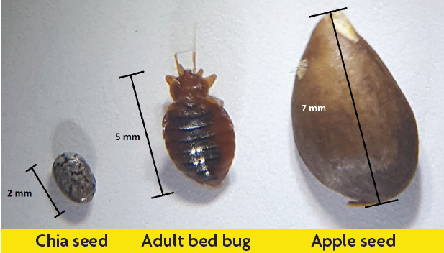
Bed Bugs
Bed bugs, also known as red coats, mahogany flats, and wall lice, have been with humans since the beginning of time. Today, bed bugs are a problem all over the world including Alaska. Bed bug infestations are not a result of a dirty home and are common in homes and hotels across the world.
Bed bugs are attracted to the carbon dioxide that we exhale while breathing. When there are less than 500 bed bugs in a dwelling, they tend to mostly come out at night. However, when there are more than 500, they can come out during the day too. Many bugs look similar to bed bugs, so it is important to positively identify the bug before treatment.
People often use “bug bombs” in their homes, which will kill some pests, but are not effective against bed bugs. During a mild infestation, bed bugs tend to stay close together within a 3-foot area of where people sleep. A “bug bomb” will not kill bed bugs, but will it make them spread out to other areas in the house. Also, some people try to freeze out bed bugs, but the cold does not kill them and they can live as long as a year without food.
What do you do if you think you have bed bugs?

First, capture one and identify it. Once it has been positively identified as bed bug, then use home treatments, including:
- Cleaning out as much clutter as possible and avoid moving items between rooms.
- Inspect items and if bug-free, store in plastic bags or totes. Run clothes and sheets through a dryer cycle and store them in plastic bags or totes.
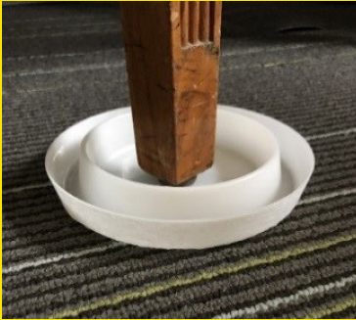
- Encase pillows, box springs, and mattresses in plastic covers specifically designed to entrap bed bugs. Leave these covers on as they will prevent bed bugs from getting in or out.
- Move furniture and beds away from the walls.
- Place traps under the legs of beds and furniture and check them daily to locate where the bed bugs are gathering.
- Find all their hiding spots and physically remove the bugs.
- Bed bugs can hide in mattress seams, on bedframes and in screw holes, behind picture frames, behind baseboards, and many other places.
- If a vacuum is used, be sure to seal the bag or emptied debris before throwing it away and thoroughly clean the vacuum cleaner afterwards.
- For items that can be placed in the dryer, 30 minutes in a dryer set on high will kill the bedbugs in all stages of life.
Bed bugs are a pain, but with a little effort you can remove them from your home yourself and eliminate the need for chemical use or hiring an expensive exterminator. For more information, please contact the ANTHC Environmental Health Program at (907) 729-4043 or ceh@anthc.org.

