Carbon Monoxide
Alaska is the second most deadly state when it comes to carbon monoxide(CO) poisoning. CO is a colorless, odorless gas that is often called the silent killer. Between 1993 and 2010, 149 people in Alaska were hospitalized from CO poisoning. Alaskans die due to CO poisoninig every year.
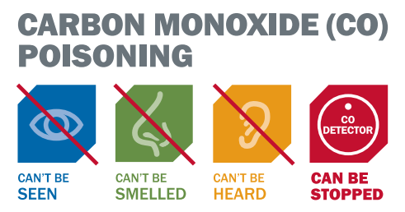
CO comes from vehicles and appliances that burn fuel like cars, snowmachines, woodstoves, toyostoves, boilers, water heaters and other sources. It can build up inside homes and poison the people who breathe it. It becomes a bigger concern during the winter, when we spend more of our time indoors.
CO poisoning symptoms are often described as “flu-like” and include: headache, dizziness, weakness, upset stomach, vomiting, chest pain, confusion, and unconsciousness. If you have these symptoms, you should get outside and seek medical help. Sometimes CO poisoning kills people who are sleeping even before they notice any symptoms. The best way to protect yourself and family is to install CO monitors in your home that will alert you when CO is present.
CO poisoning is preventable if you:
- Install battery operated CO detectors in your home. Replace batteries when needed and replace the detector itself every 5 years.
- Maintain your oil and gas burning appliances.
- Never patch a vent pipe with tape, gum, or something else.
- Never use a generator inside your home or garage.
- Never use a generator or idle your car within 20 feet of a window, door, or vent.
- Always seek medical help if you think you have CO poisoning or are feeling light-headed and nauseous.
- Teach children what to do if the alarm sounds.
- Make sure your home is ventilated so the CO has somewhere to escape
Alaskans are at an increased risk of CO Poisoning, but following the easy steps outlined above can help protect you and your family. For more information, please visit: https://www.cdc.gov/co/default.htm or contact the ANTHC Field Environmental Health Program at (907) 729-4043 or ceh@anthc.org.

