Food Safety
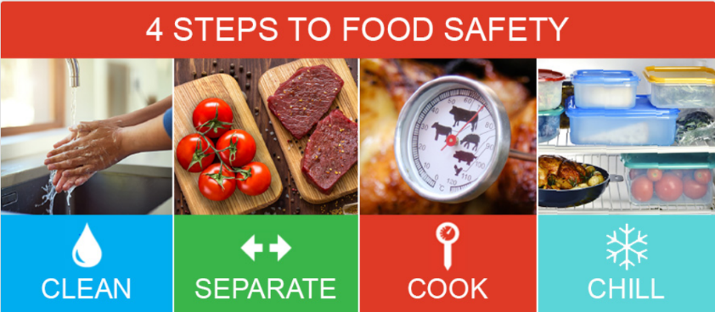
Every year, people get sick or end up in the hospital with foodborne illnesses. Food can sometimes be contaminated by bacteria or viruses, like E. coli or Salmonella, that can make us sick. Contaminated food can lead to upset stomach, cramps, fever, diarrhea, vomiting, and many other more serious symptoms. The best way to keep your family safe from foodborne illness is to follow these four steps: clean, separate, cook, and chill.
Clean
- Wash your hands before, during, and after preparing food and after touching raw meat, poultry, seafood, or eggs.
- Wash cutting boards, dishes, knives, and other cooking utensils with hot soapy water especially after using them to prepare raw meat, poultry, seafood, or eggs.
- Wash fruits and vegetables under running water.
- Do not wash meat, poultry, and eggs since that can spread harmful germs around your kitchen and proper cooking will kill any germs.

Separate
- Use one cutting board for ready to eat food and a second for raw meat, poultry, or seafood.
- Use separate plates and utensils for raw foods.
- Keep raw meat, poultry, and seafood in sealed containers and away from produce and other food in the refrigerator.

Cook
- Cook food to the correct minimum internal temperature. Use a food thermometer to check.
  - Duck, goose, and other poultry – 165°F
  - Ground meat (beef, moose, caribou, lamb, deer, pork) – 160°F
  - Steaks, chops, and roasts (beef, moose, caribou, lamb, deer, pork) – 145°F
  - Fish – 145°F
- Store hot food at 140°F or hotter if not eating it right away.

Chill
- Refrigerate food within 2 hours.
- Divide food into several shallow containers to help it cool faster.
- Thaw food in the refrigerator not on the counter.

Be sure to throw out food if it has spoiled or is no longer safe to eat. Also avoid eating foods with uncooked eggs or flour like cookie dough because they may contain harmful bacteria. Food should help give us energy and keep us healthy, not make us sick. Following these basic food safety tips will help keep you and your family safe from foodborne illnesses. For more information, please contact the ANTHC Field Environmental Health Program at (907) 729-4043 or ceh@anthc.org.

