Mold Prevention
There are over 100,000 known species of mold on earth. Some mold is helpful, like the mold used to make cheese or medicine like penicillin. However, other mold is unwanted, like the mold growing in our homes. Mold in homes can trigger health issues like coughing, runny nose, dizziness, and asthma symptoms, as well as cause structural damage to the home.
The key to mold prevention is maintaining healthy moisture levels by monitoring and controlling humidity and ventilation in your home. Humidity is the amount of water in the air. Controlling humidity is important because mold only grows in wet environments. Humidity levels can increase when we cook, shower, do laundry, or even just breathe. Some amount of humidity in our homes is normal, but high levels encourage mold growth.
You can tell if you have high humidity in your home with a hygrometer, which are available online or at some hardware stores. These can be very inexpensive. The humidity level in your home should be between 30-50%. Other signs that your home’s humidity level may be too high is if there is condensation (water) on your windows or you if can see or smell mold. Tips for lowering moisture levels and preventing mold growth include:
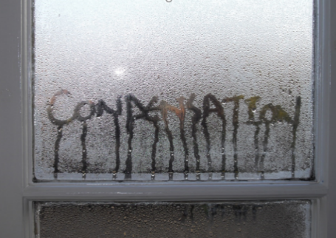
- Using ventilation fans or opening windows while cooking, showering, or when you have many guests.
- Using de-humidifiers or fans.
- Repairing leaky pipes, vents and roofs quickly.
- Minimizing clutter.
- Moving furniture 3 inches away from the wall.
- Storing firewood outside.

Preventing the wet conditions that mold needs to grow is the most effective step, but cleaning up the existing mold is also important. Keep in mind that if you clean the mold, but do not fix the moisture problem, the mold will most likely come back. General mold clean-up recommendations include:

- Hard surfaces-scrub with detergent and water, rinse and let dry completely.
- Soft surfaces- items like couches, carpets, and ceiling tiles may have to be thrown away if you cannot completely clean and dry them.
- Always wear protective gear, including face masks, gloves, and eye protection.
- Call a professional if the job is too big, complex, or dangerous.

Mold is a common issue, but with a little effort it can be controlled and removed from your home environment. For more information visit: https://www.epa.gov/mold/brief-guide-mold-moisture-and-your-home or contact ANTHC Field Environmental Health Program (907) 729-4043 or ceh@anthc.org.

