Paralytic Shellfish Poisoning
Paralytic shellfish poisoning (PSP) is a serious illness caused by eating shellfish that have been contaminated with toxins called saxitoxins. These toxins are produced naturally when shellfish eat algae during a harmful algal bloom (HABs). HABs occur when the algae grow out of control and are thought to happens when there are favorable winds, currents, and warmer temperatures.
People can become exposed to the toxins when they eat shellfish that have fed on HABs. Early signs that someone has PSP are numbness and tingling of the lips and tongue that moves down to the fingers and toes. If the poisoning goes untreated, the person can lose muscle control and have difficulty breathing. Depending on the amount of toxins consumed, it can lead to paralysis or even death.
In Alaska, PSP is a year-round concern for anyone that eats shellfish that are not commercially harvested. Sometimes HABs cause “red tides” that change the color of the water, but you cannot tell if there are toxins just by the water’s appearance. PSP toxins can be present even in clear water. HABs are often not visible and are only discovered through commercial testing of the shellfish.
There are 20,000 species of shellfish that can contain the toxin. Some species like butter clams and blue mussels can even keep the toxin for many months. Alaskans should be careful of:
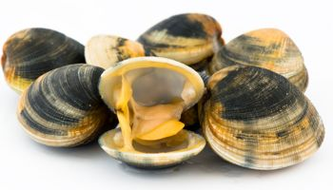
- Clams
- Mussels
- Cockles
- Crab (guts/butter)
- Geoducks
- Oysters
- Scallops

Freezing and or cooking shellfish will not kill the toxin.
Although there is no antitoxin, people who have been poisoned can possibility survive if they receive immediate medical care. If you think you or a loved one have PSP, contact your health care provider right away.
Knowing the risks, signs and symptoms of PSP can save your life. For more information visit : http://dhss.alaska.gov/dph/Epi/id/Pages/dod/psp/default.aspx or contact the ANTHC Field Environmental Health Program at (907) 729-4043 or ceh@anthc.org.

