Preventing Foodborne Botulism
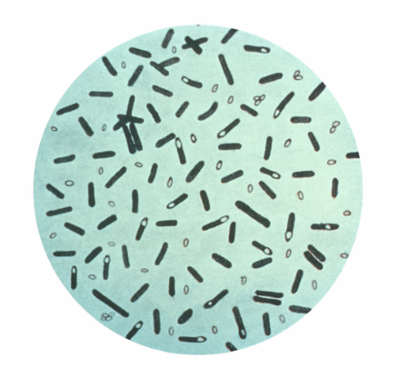
Botulism is a serious illness caused by bacteria that naturally lives in our environment. The bacteria live in both soil and untreated water.
Botulism spores (seeds) can survive in harsh environments and thrive where there is no oxygen like in a warm Tupperware container, wrapped in plastic, or in a sealed 5-gallon bucket. Although considered rare in the lower 48, there have been over 100 foodborne botulism outbreaks in Alaska since 1919. These outbreaks are often due to fermenting food by using non-traditional methods and materials like plastic containers that do not allow for air flow.
Foodborne botulism is harmful to the nervous system. Early on, people have fatigue, nausea, vomiting, and dry mouth. If treated early with an antitoxin, people can survive the poison. If not treated, the toxin may lead to difficulty breathing, paralysis, and death. Sometimes, the person will survive but can continue suffering the effects for many years. Symptoms can start anywhere between 4 hours and 8 days after eating the toxin.
To help prevent botulism poisoning:
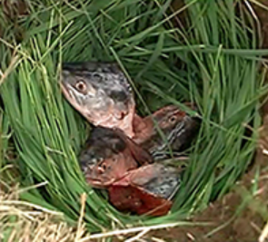
- Do not ferment food in sealed plastic containers.
- When fermenting food, use traditional methods that use the cold ground with grass, or leaf wraps and allow oxygen to circulate.
- Boil fermented food before serving for a minimum of 10 minutes and reach 212°F internally.
- Always wash hands and food containers before preparing and handling food.
- Keep raw and uncooked foods separate from ready to eat food.
When fermenting foods, traditional methods and materials are best. Even plastic containers with the lids left open can grow botulism if the air cannot get to the bottom or side of the food while it’s fermenting.
Botulism poisoning is a deadly illness that is still too common in Alaska. Following proper food safety and fermenting practices will help prevent you and your family from getting seriously sick. For more information, please contact the ANTHC Field Environmental Health Program at (907) 729-4043 or ceh@anthc.org.

