Protecting Health and Property During a Volcanic Ashfall
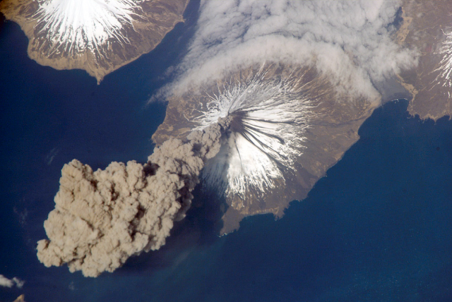
Alaska is a part of the pacific ring of fire and has long had volcanic activity. The Aleutian chain, the Pribilof Islands, and Mt. Edgecumbe in Sitka were all formed by volcanoes. Many of Alaska’s volcanoes are still active today.
Volcanic ash is harmful if inhaled because it is mostly made up of tiny shards of rock. If an ashfall occurs during daylight hours, the sky may turn murky gray. Ashfall can be disorientating for mariners or those traveling across the land. During volcanic ashfall there is often thunder, lightning, and a strong smell of sulfur. If it rains during an ashfall, the ash can mix with the water to create slippery mud. Falling ash may also block sound. Survivors of volcanic ashfalls report “intense quietness” or “deadness to normal sounds of life”.
Cleveland volcano erupting in the Aleutian chain, photo graphed by the international space station, May 2006
Steps to protect health and property:
- Take shelter from the falling ash.
  - Avoid breathing in the ash and close windows and doors.
- If the building has a ventilation system that brings in outside air, turn it off.
  - Air-conditioning, heating, and ventilation (HVAC) systems can break if ash blocks the filters, condensers, and air intakes.
- If venturing out into the falling ash, wear a respirator and eye protection.
  - Do not wear contact lenses (volcanic ash can get under the lens and scratch your eye).
  - In the short term, ash can cause eye irritation and worsen existing respiratory diseases.
  - Serious health problems are rare and usually occur from accidents that occur during clean up after the ashfall.
If you have food in a garden, it is still edible after being washed. Do not use dishwashers or washing machines with water that is contaminated with ash. Water contaminated by ash will usually look, taste or smell bad, but if you must drink it, be sure to:
- Let the water sit for as long as possible to let the ash to settle in the bottom of the container.
- Use only the water from the top of the container.

Alaska has many active volcanoes and while eruptions and ashfall events may not happen very often, we still need to be prepared. Eruptions often happen without warning so knowing what to do ahead of time can help protect your health and property during these sudden events. For more information on volcanic ash, please visit : https://volcanoes.usgs.gov/volcanic_ash/health.html or contact the ANTHC Field Environmental Health Program at (907) 729-4043 or ceh@anthc.org.

