Road Dust
Road dust is a common issue all over Alaska. Road dust doesn’t only reduce visibility and annoy us; it also can harm the health of our elders, children, and neighbors. Sometimes the wind can blow road dust around, but usually it gets kicked up from driving. ATVs are especially bad at kicking up dust because their tires are so big and knobby.
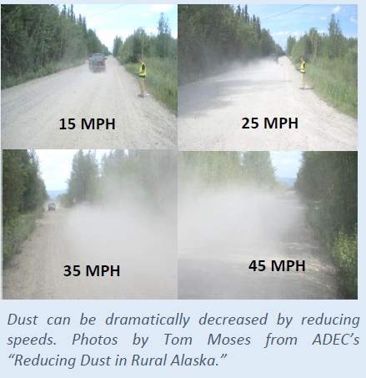
Road dust is not only made up of dirt from the road, but also anything that was on the road’s surface. This means road dust could also include oil, gas, metals, and even human or animal feces. The bigger dust particles can get into our mouths, noses, and lungs, making it difficult to breathe or cause irritation. The smaller dust particles, that we can’t even see, can get deeper into our bodies and make us sick; worsening asthma and other health issues.
Fortunately, there are ways to reduce road dust, including applying chemicals to road surfaces, paving roads, or using a water truck when it’s dry. However, the cheapest and easiest solution is simply driving a little slower. Taking an extra few minutes to get where you are going can greatly reduce road dust. For example, slowing down from 40 mph to 20 mph can reduce the amount of road dust by 30%. Another good solution, when possible, is walking or biking instead of driving.
When driving, we should keep our neighbors health and air quality in mind and…
- Drive slower and teach kids to drive slower.
- Avoid slamming on the gas or breaks.
- Keep a respectful distance from other drivers and pedestrians.
While we need vehicles to work, travel and provide for our families, we should always be sure their use does not impact the health and wellness of our community. For more information, please contact the ANTHC Field Environmental Health Program at (907) 729-4043 or ceh@anthc.org.

